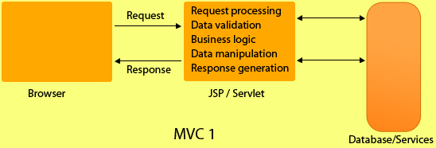

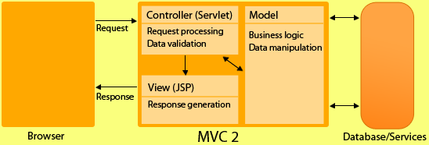

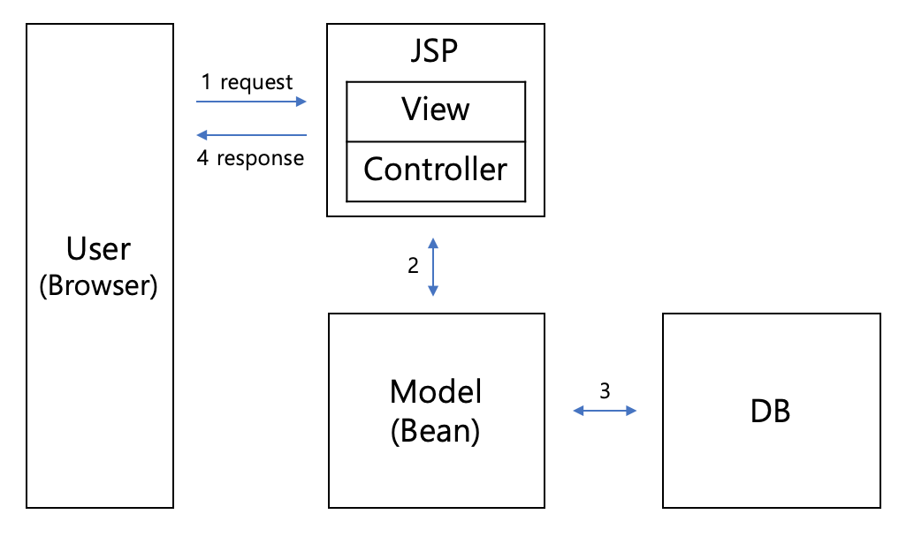

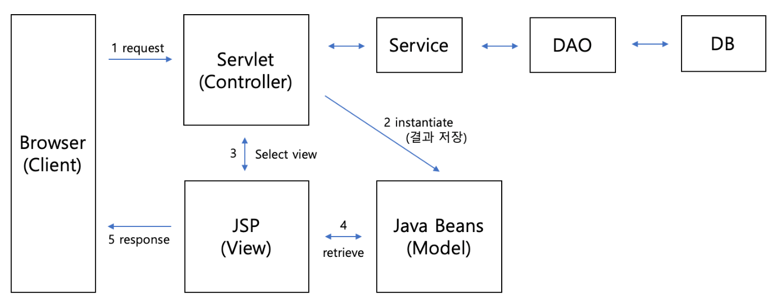

|  |  |
| --- | --- |
| **MVC 1** | **MVC 2** |
| In MVC1, only one component is responsible for receiving request and sending response. | In MVC2, there is separate components for receiving and sending response. i.e. Controller & View. |
| MVC1 associates the presentation logic with the business logic. | MVC 2 isolates or disassociates the presentation logic from business logic. |
| In MVC 1, business logic and presentation Logic is combined so web designer and web developer cant work simulateously. | Since both logics are separate that's why designer and developer can work together. |
| Doesn't support reusability of application components. | Reusability of components. |
| In MVC 1, controller and model,both are JSP. | While controller is servlet and model is java class. |
| In MVC1 there is tight coupling between page and model as data access is usually done using Custom tag or through java bean call. | In MVC2 architecture there is only one controller which receives all the request for the application and is responsible for taking appropriate action in response to each request. |